Fiscal Sheet for a Medieval Lord: Demesne, Realm, Tithes and Taxes
Oct 9, 2026 · @Alex
In an ordinary year Winterfell takes in 273,168 GD of cash after its estates pay their running costs. It spends 11,450 GD on household and works, sends 40,975 GD to the Crown, and keeps 220,743 GD. This sheet follows each dragon from the farm that earned it to the account that holds it.

How to use this sheet
This sheet keeps the books of one great lord, House Stark of Winterfell, through one ordinary year, 126 AC. Each section opens with its point and then shows the figures behind it.
Colour means the same thing in every chart. Blue is tribute, paid up the chain to a higher lord. Grey is everything else, and the dark bar marks the one thing a chart is about. Green and red appear only in the grain account, for grain added and grain used.
Every figure is a simulation choice, not a record: the setting supplies the houses and their allegiances, and the model supplies the numbers. Money is in gold dragons (GD), with 210 silver stags to the dragon and 56 copper pennies to the stag. Grain is in quarters of 8 bushels. Time is in moons, about 30 days each, twelve to the year.
Layer | What it covers | Sections
All levels together | Flows between every party, the trade account, tribute and deficits | The money map; Account by level
The demesne | The share of each estate's farm output the lord works in hand: grain, stock, hired labour | The lordship at a glance; The demesne; Demesne income and production costs; Where the harvest went
The wider realm | Tenants' rents, leases, mills, markets and courts on Winterfell's 12 estates, and the 51 houses beneath it | The wider realm; Profits of lordship
Church dues | No general tithe in the North: godswood upkeep, alms and septon support instead | Tithes and church revenues
Crown and bannermen | Tribute from 35 bannermen up to Winterfell, Winterfell's payment to the Crown, royal port customs | Tributes and taxes
Outgoings and balance | Household, castle, works, the audited account, calendar, risk | Household, castle and works; The annual account; The seasonal calendar; Risk, deficits and contingency
Three rules keep the sheet honest:
- Charge and discharge. Everything received is charged to the lord, everything paid out is discharged, and the difference is the balance carried forward.
- Count each dragon once. Rents, tribute and Crown payments move output from one hand to another; they are never added to output.
- Keep owed coin apart from coin in the chest. What is due, what is paid and what stays owing are three figures, and arrears are a receivable, not cash.

The money map
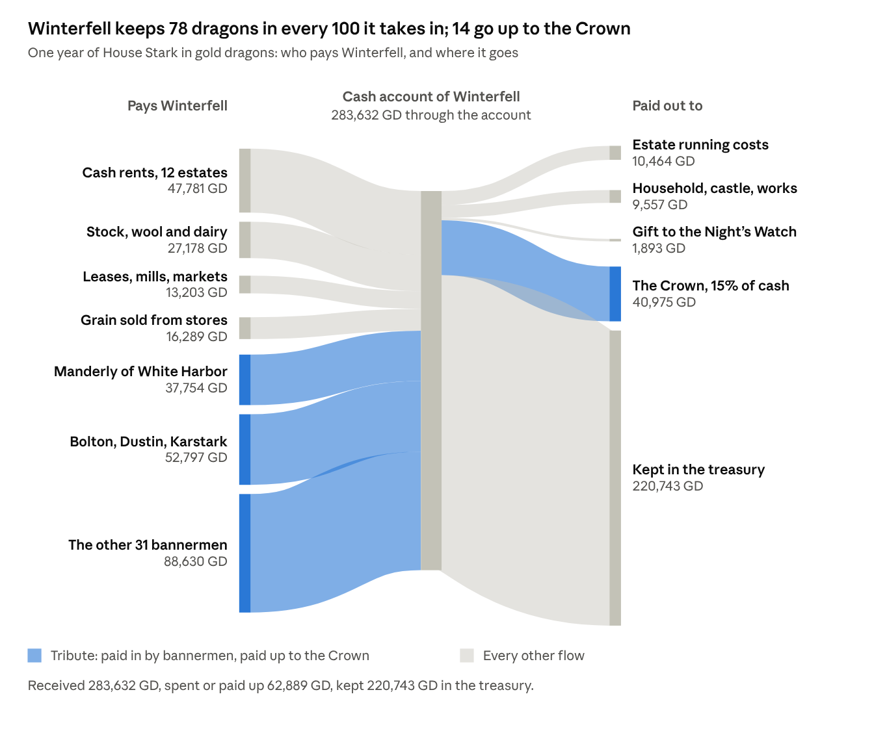
House Stark, one year · cash only; grain moves in quarters and is not drawn (see the grain account)
Read left to right. Winterfell takes in 283,632 GD: 179,181 GD of tribute from 35 bannermen, 47,781 GD of tenants' rents, and 56,670 GD from its own stock, leases and grain. Tribute is 63 percent of the inflow. Of the whole, 220,743 GD stays in the treasury, 40,975 GD goes to the Crown, and 21,914 GD pays for the estates, the household and the Night's Watch gift.
The Crown also takes 58,035 GD of royal customs at six ports. That money never passes through a house's account, so it is not drawn here; it appears in the Crown's receipts under Tributes and taxes.

The money map for one moon
The workbook counts a year, not a moon, so the moon figures here are the year cut into pieces. A moon is about 30 days and twelve make a year. The sheet fixes one thing: the bannermen and the Crown are paid in two instalments, 60 percent and then 40 percent. It gives no dates for them. I put the instalments in moons 4 and 10, six moons apart, and spread everything else evenly over the twelve. Move the instalments and the yearly totals do not change.
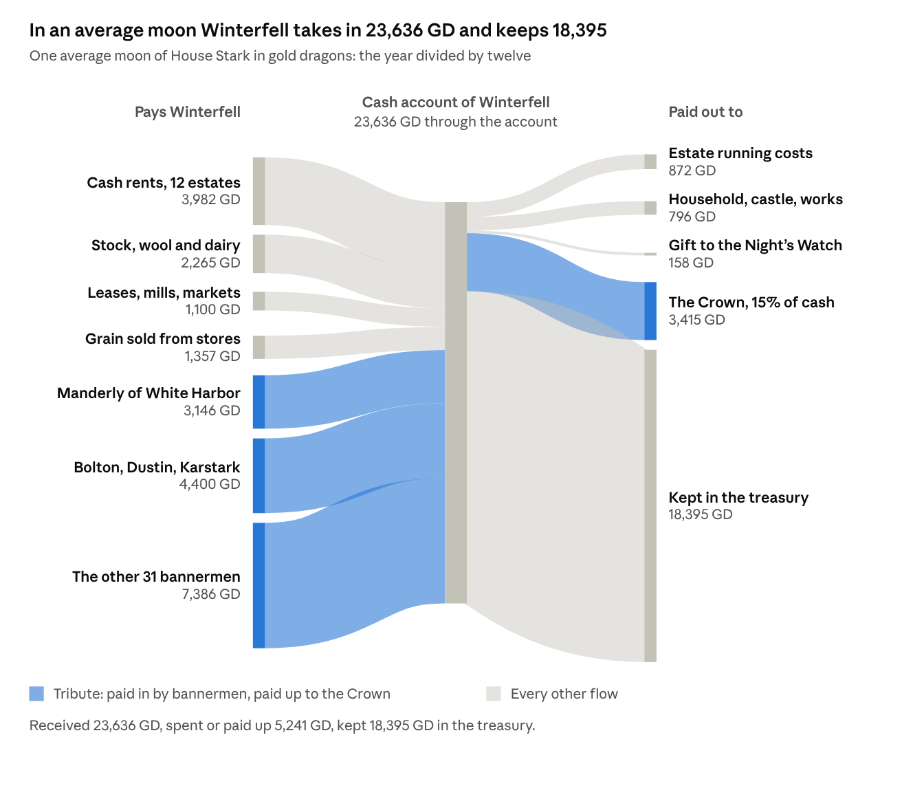
House Stark, one average moon, GD · the yearly money map divided by 12
This is the year divided by twelve. It is true on average and wrong in almost every actual moon, because the bannermen do not pay every moon.
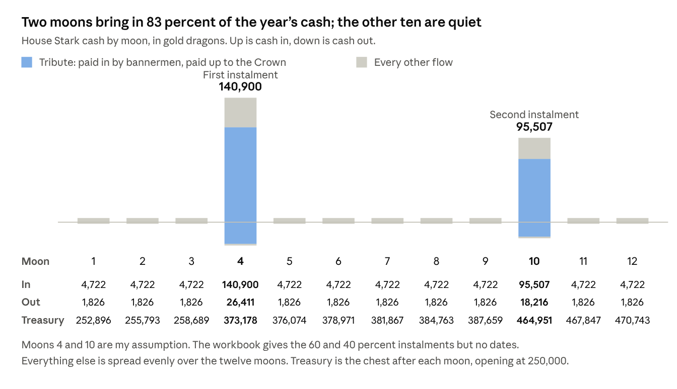
House Stark, by moon, GD · instalment moons are my assumption
Two moons bring in 83 percent of the year's cash. The other ten bring in about 4,700 GD each and spend about 1,800, so every quiet moon still adds about 2,900 GD to a chest that opens the year at 250,000.
Per moon, in gold dragons. Out is costs plus the Crown. Kept is what is added to the treasury. Rows are rounded and may differ by 1.
Kind of moon | Cash in | Cash out | Kept
Average moon, the year divided by 12 | 23,636 | 5,241 | 18,395
Quiet moon, 10 of them | 4,722 | 1,826 | 2,896
First instalment moon, moon 4 | 140,900 | 26,411 | 114,489
Second instalment moon, moon 10 | 95,507 | 18,216 | 77,291
The Crown is paid at the instalments, not every moon: 24,585 GD in moon 4 and 16,390 GD in moon 10.
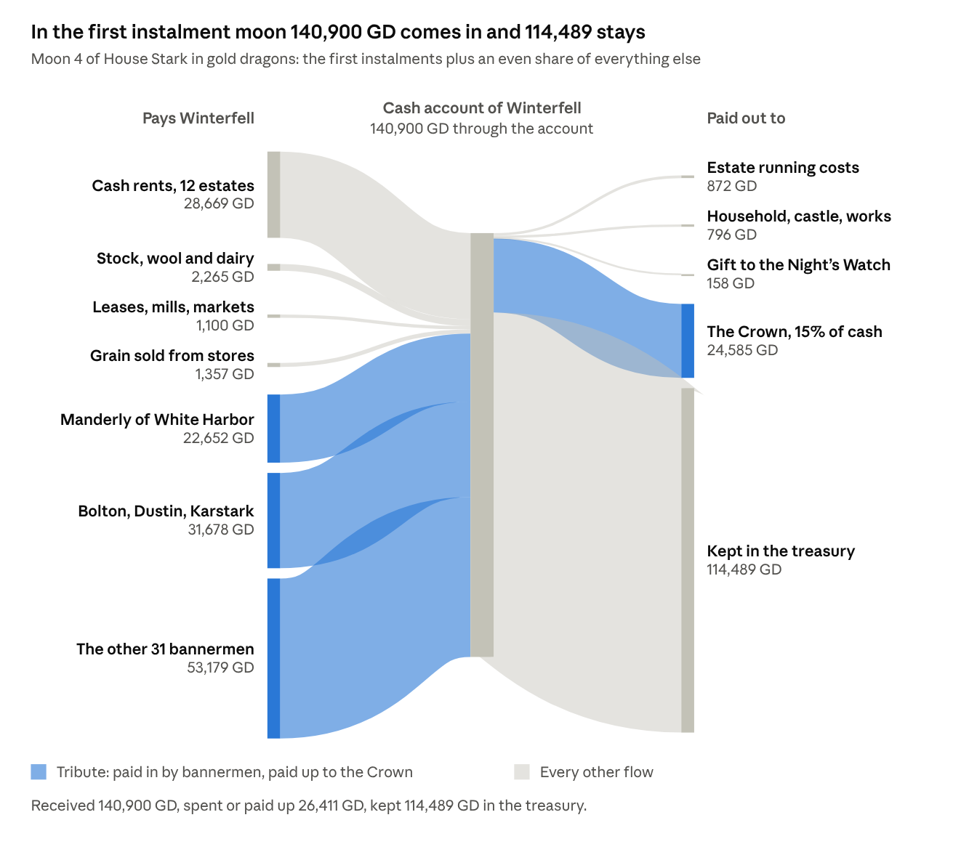
House Stark, first instalment moon (moon 4), GD
In the first instalment moon, 76 percent of the cash that comes in is tribute, and 93 percent of what goes out is the Crown's share.

Account by level
Every party in the chain keeps its own account. The table runs from the estates that earn the money, up through the houses, to the Crown, and shows what each level receives, spends, passes up and keeps.
Level | Cash received | Running and household costs | Paid to the level above | Kept in treasury
163 estate receivers, 800,000 households | 983,004 | 114,020 | 868,984 to their houses | 0
16 sub-vassal houses | 85,446 | 11,784 | 13,559 to five overlords | 60,104
35 direct bannermen | 858,082 | 90,925 | 179,181 to Winterfell | 587,975
Winterfell (House Stark) | 273,168 | 11,450 | 40,975 to the Crown | 220,743
The Crown, from the North | 99,010 | not in the sheet | none | not in the sheet
All figures are GD for one year. Tribute is counted once as paid by the lower house and once as received by the higher one, so the columns do not add across levels. Only the last column does: 60,104 + 587,975 + 220,743 = 868,822 GD. The Crown's 99,010 GD is Winterfell's 40,975 GD plus 58,035 GD of royal customs. Figures are rounded, so a row may differ by 1.
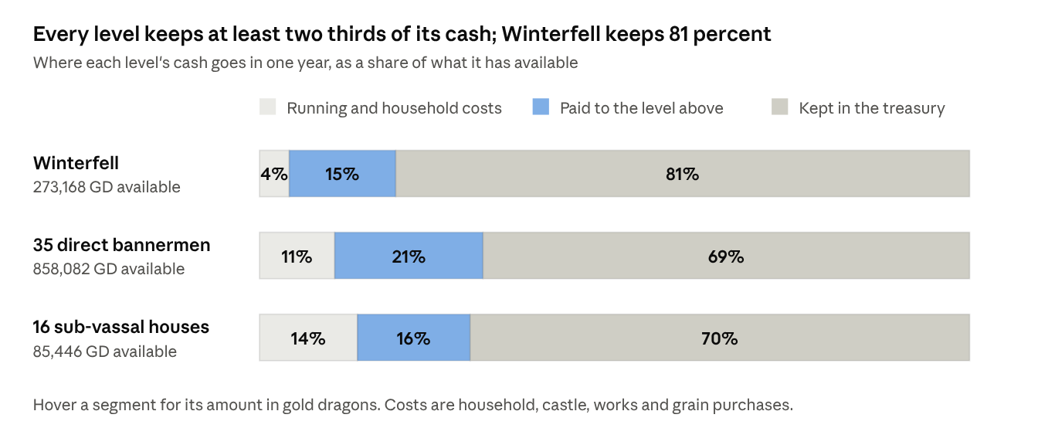
House Stark and its bannermen, one year · House Accounts sheet
Blue is tribute, the same blue as the money map. The share paid up is 15 to 21 percent at every level; the rest is costs and the surplus kept.

The trade account
Winterfell is also a trader. It sells stock, grain, timber and fish, and pays for the labour and gear that produce and carry them. The sheet does not split estate costs between rents and trade, so this account sets all of them against trade receipts, the cautious reading.
Trade account, Winterfell | GD
Livestock, wool and dairy, the lord's share | 27,178
Grain sold from the granaries (236,735 quarters) | 16,289
Timber leases | 3,809
Fishery leases | 1,064
Trade receipts | 48,340
Permanent farmworkers (3,411) | 1,937
Seasonal harvest labour (341,080 worker-days) | 659
Replacement oxen and sheep | 1,851
Ploughs, tools, sacks, carts and harness | 4,521
Cartage and store labour | 1,292
Receivers and tally clerks | 204
Trade expenses | 10,464
Trade surplus | 37,876
The surplus after all estate costs is 37,876 GD; Winterfell buys no grain. Across the whole North the sheet sells 1,347,318 quarters of grain abroad for 96,596 GD and imports none.

The deficits
No house in the sheet runs a cash deficit: every treasury ends the year higher than it began. The shortfalls that do appear are arrears, coin and grain owed but not yet paid. Risk, deficits and contingency tests four ways a real deficit could open.
- Tenants' rents. Tenants across the North owe 16,332 GD of cash rent after the lawful remission, 949 GD of it on Winterfell's 12 estates, and 20,191 quarters of grain rent, 1,478 of them at Winterfell.
- Bannerman tribute. Winterfell's 35 bannermen owe 181,571 GD and pay 179,181 GD. The 2,390 GD left owing is 1.3 percent, the most from Manderly (381) and Umber (316).
- Grain. Winterfell sells 236,735 quarters and still closes with 71,879; no tenant or house closes with negative grain.

The lordship at a glance
Winterfell's own estates hold 72,480 of the North's 800,000 households, 9 percent, yet Winterfell is paid by the other 91 percent through its bannermen. The table sets the demesne lord's own lands beside the whole realm.
Item | Winterfell's 12 estates | The North, 163 estates | Winterfell's share
Households | 72,480 | 800,000 | 9.1%
People (5 per household) | 362,400 | 4,000,000 | 9.1%
Rural households | 68,216 | 742,667 | 9.2%
Sown acres (14 per rural household) | 955,024 | 10,397,338 | 9.2%
Gross harvest, quarters | 1,134,482 | 11,405,588 | 9.9%
Permanent estate workers | 3,411 | 37,137 | 9.2%
Output, value added (GD) | 297,412 | 3,300,000 | 9.0%
Gross cash to the lords (GD) | 88,162 | 983,004 | 9.0%
Houses | 1 | 52
The North is the poorest region in the sheet: 3,300,000 GD a year, against 9,000,000 for the Reach and 5,400,000 for the Westerlands. Dorne ranks second at 7,500,000 and pays the Crown nothing. These regional figures are simulation assumptions.
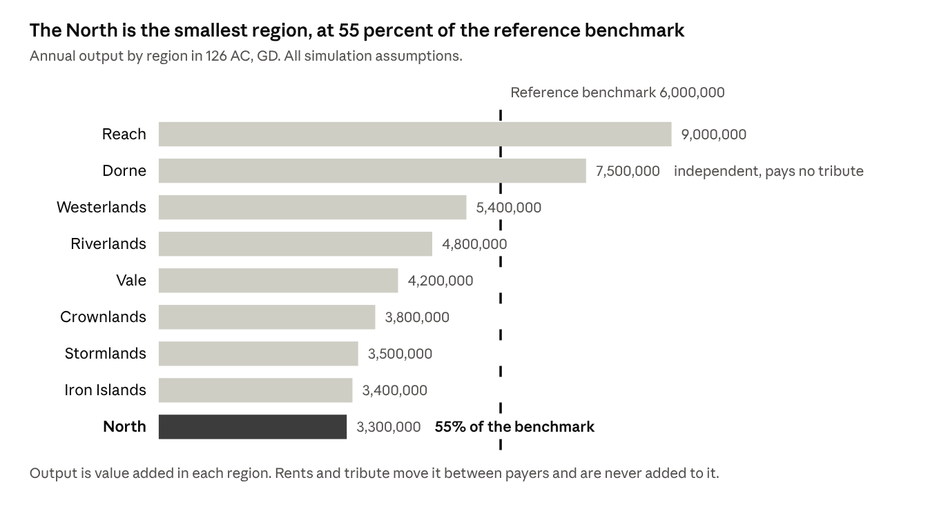
North and the other regions, 126 AC, GD · Regional GDP 126 sheet
The dark bar is the North. The dashed line is the 6,000,000 GD reference output that the workbook scales the North against. The Westerlands bar sits below the line at 5,400,000 because the sheet applies a factor of 0.9 for 126 AC.
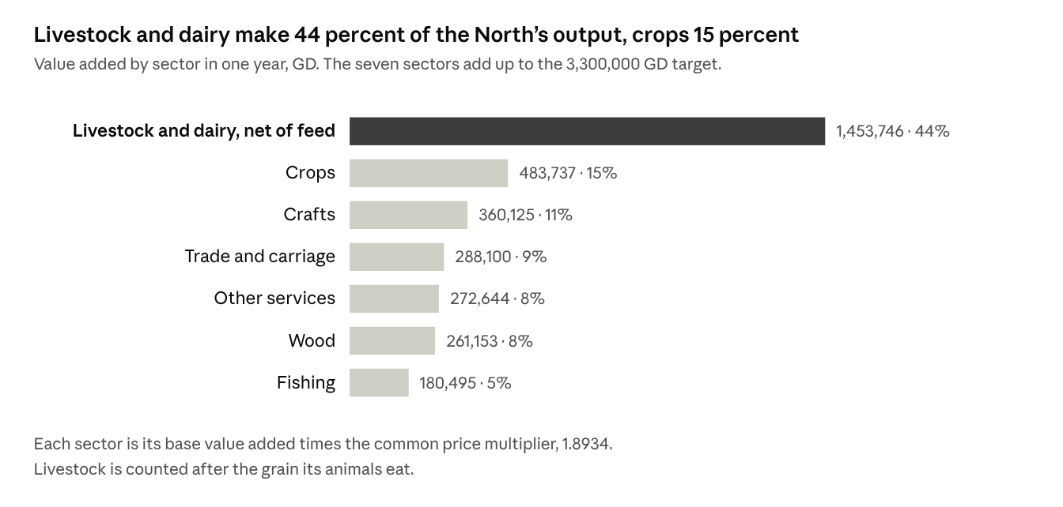
The North, one year, GD · Economy sheet, base value added times the price multiplier
Livestock and dairy are 44 percent of what the North produces and crops are 15 percent. That mix is the workbook's own, and it is kept unchanged here.
Two houses beneath Winterfell hold more households than its own estates: Manderly of White Harbor with 99,661 and Bolton of the Dreadfort with 77,011. Dustin of Barrowton, with 54,360, comes next. Winterfell's strength is the right to tribute, not the size of its home farms.

Money, weights and measures
The sheet counts money in three coins and grain in one measure. Every account is in gold dragons (GD) for cash and in quarters for grain, and the two are never added together.
Unit | Equals | Note
Copper penny | 1/56 of a stag | The smallest coin; 11,760 to the dragon
Silver stag | 56 pennies, 1/210 of a dragon | Wages and rents are quoted in stags
Gold dragon (GD) | 210 stags, 11,760 pennies | The unit of every cash account in this sheet
Bushel | 1/8 of a quarter | Dry measure for grain
Quarter | 8 bushels | The unit of every grain account; a bushel of oats weighs 32 lb, barley 48, rye 56, peas and beans or wheat 60
Sown acre | Land sown in the year | Excludes fallow and grazing; 14 per rural household
Stone of 14 lb | A weight | Wool, dairy at milk-equivalent weight and preserved fish are counted by the stone
Cartload | A load | Dressed timber, delivered locally
Every price comes from one schedule, fixed in silver stags and converted to dragons at one common scale. The scale, 1.8934, is set so that the North's output comes to 3,300,000 GD, which is 55 percent of the 6,000,000 GD Westerlands benchmark. Quantities such as households, acres and quarters do not move with it. A year's cash pay for a foot retainer, 3.79 GD, buys 60 quarters of rye.
Item | Unit | GD | Silver stags
Rye | quarter | 0.063 | 13.3
Barley | quarter | 0.072 | 15.1
Oats | quarter | 0.045 | 9.5
Peas and beans | quarter | 0.090 | 18.9
Wheat | quarter | 0.108 | 22.7
Permanent farmworker, cash pay (grain extra) | year | 0.568 | 119.3
Foot retainer, cash pay (grain extra) | year | 3.787 | 795.2
Mounted retainer, cash pay (grain extra) | year | 7.573 | 1,590.4
Steward | year | 18.934 | 3,976.1
Slaughter cattle | head | 1.325 | 278.3
Replacement working ox | head | 0.947 | 198.8
Breeding sheep | head | 0.316 | 66.3
Dressed timber | cartload | 0.379 | 79.5
Timber granary, 1,000 quarters | building | 189.34 | 39,760.6
Stone curtain wall | 10-yard section | 284.00 | 59,640.9
Coastal cargo vessel, about 100 tons | hull and rig | 1,893.36 | 397,606.1
Cash gift to the Night's Watch | year | 1,893.36 | 397,606.1

The demesne
The demesne is the fifth of each estate's farm output that the lord keeps; tenants hold the other four fifths. On Winterfell's 12 estates that is 226,896 of 1,134,482 quarters of grain a year. The sheet divides output, not fields, so it names no demesne acreage.
Estate | District | Households | Sown acres | Permanent workers
Winterfell home farms | Lowland | 10,014 | 131,782 | 471
Winter Town plots | Town | 500 | 2,100 | 8
East meadow villages | Lowland | 7,510 | 98,826 | 353
West meadow villages | Lowland | 5,946 | 78,246 | 279
Upper White Knife farms | Lowland | 8,449 | 111,188 | 397
Kingsroad northern holdings | Lowland | 4,694 | 61,768 | 221
Kingsroad southern holdings | Lowland | 6,259 | 82,362 | 294
Western woodland leases | Forest | 6,884 | 93,478 | 334
Northern sheepwalks | Upland | 5,007 | 68,698 | 245
Southern cattle country | Lowland | 7,197 | 94,710 | 338
Mill and bridge villages | Lowland | 5,633 | 74,130 | 265
Winterfell outlying farms | Lowland | 4,387 | 57,736 | 206
Total |  | 72,480 | 955,024 | 3,411
Nine estates are lowland, one is forest, one upland and one is the town of Winter Town. The estate names are constructed for the simulation; each is a group of villages, fields and leases under one receiver.
Crop | Sown acres | Gross harvest (q) | Demesne harvest (q) | Demesne seed (q) | Demesne loss (q) | To the granary (q)
Rye | 295,855 | 314,049 | 62,810 | 14,793 | 3,140 | 44,877
Barley | 230,647 | 308,812 | 61,762 | 17,299 | 3,088 | 41,375
Oats | 212,853 | 277,461 | 55,492 | 21,285 | 2,775 | 31,432
Peas and beans | 131,710 | 142,511 | 28,502 | 6,585 | 1,425 | 20,492
Wheat | 83,959 | 91,649 | 18,330 | 4,198 | 916 | 13,216
Total | 955,024 | 1,134,482 | 226,896 | 64,160 | 11,345 | 151,391
Seed takes 28 percent of the demesne harvest and storage and harvest loss another 5 percent, so 151,391 quarters, 67 percent, reach the granary. Rows are rounded; the total is rounded from the exact figures.
Labour and stock the demesne needs | Quantity | Rule in the sheet
Permanent farmworkers | 3,411 | 0.05 per rural household
Seasonal harvest labour | 341,080 worker-days | 5 days per rural household
Replacement oxen | 819 head a year | 0.012 per rural household
Replacement sheep | 3,411 head a year | 0.05 per rural household
Receivers and tally clerks | 54 | One per estate, one more for each 1,500 households
Permanent workers draw grain through the lord's granary in addition to their cash pay. Seasonal labour is paid in cash only.

Demesne income and production costs
The demesne earns cash from the lord's one-fifth share of livestock, wool, dairy and timber, and 12 percent of the fisheries. Its grain comes in kind and is accounted separately. The estates then pay their own running costs before anything is sent to Winterfell.
Product | Annual output | Output value (GD) | Lord's share or lease rate | To the lord (GD)
Slaughter cattle | 23,876 head | 31,644 | 20% | 6,329
Breeding sheep | 102,324 head | 32,289 | 20% | 6,458
Pigs | 34,108 head | 12,916 | 20% | 2,583
Raw wool | 136,432 stone | 7,380 | 20% | 1,476
Milk and dairy | 2,728,640 stone | 51,663 | 20% | 10,333
Dressed timber, leased | 50,291 cartloads | 19,044 | 20% | 3,809
Preserved fish, leased | 95,587 stone | 8,868 | 12% | 1,064
Total |  | 163,804 |  | 32,051
The first five lines, 27,178 GD, are what the sheet calls livestock sold from the demesne; timber and fish are leases. Rows are rounded and may sum to 1 more than the total.
Production cost | Quantity | Unit price (GD) | Cost (GD)
Permanent farmworkers | 3,411 worker-years | 0.568 | 1,937
Seasonal harvest labour | 341,080 worker-days | 0.0019 | 659
Replacement oxen | 819 head | 0.947 | 775
Replacement sheep | 3,411 head | 0.316 | 1,076
Ploughs and tools | 68,216 rural household-years | 0.0284 | 1,937
Sacks and store consumables | 68,216 rural household-years | 0.0151 | 1,033
Carts and harness | 68,216 rural household-years | 0.0227 | 1,550
Receivers and tally clerks | 54 receiver-years | 3.787 | 204
Cartage and store labour | 68,216 rural household-years | 0.0189 | 1,292
Total |  |  | 10,464
The estates cost 10,464 GD to run, 11.9 percent of their gross receipts of 88,162 GD. The other 77,698 GD, 88 percent, is remitted to Winterfell. The costs cover all estate activity, rents as well as stock, because the sheet does not split them.

The wider realm: tenants, rents and bannermen
Beyond the demesne Winterfell has two kinds of people beneath it: tenants on its own 12 estates, who pay rent, and 51 houses across the North, who pay tribute. Rents come first.
Every household sits in one of four holding classes, set by fixed shares of each estate's rural households. A full farm is 60 percent of them, a smallholding 25 percent, and crofts and cottages the remaining 15 percent. Town households hold plots and workshops.
Holding class | Holdings | Rent per holding (GD) | Assessed (GD) | Remitted, 2% (GD) | Paid (GD) | Arrears (GD)
Full farms | 40,928 | 0.947 | 38,746 | 775 | 37,223 | 748
Smallholdings | 17,055 | 0.379 | 6,458 | 129 | 6,204 | 125
Crofts and cottages | 10,233 | 0.126 | 1,292 | 26 | 1,241 | 25
Town plots and workshops | 4,264 | 0.757 | 3,229 | 65 | 3,113 | 52
Total | 72,480 |  | 49,725 | 995 | 47,781 | 949
The rents are assessed first, then 2 percent is lawfully remitted, then the receiver collects what he can. Winterfell's tenants pay 98.1 percent of what is due after remission: 98.5 percent on lowland estates, 97 percent in the forest, 94 percent on the upland and 99 percent in Winter Town. Rows are rounded.
The tenants also owe grain rent, 7 percent of their harvest, which is accounted under the grain account. The 47,781 GD of cash rent is 54 percent of Winterfell's gross estate receipts.
The 51 houses beneath Winterfell form a chain. Thirty-five pay Winterfell directly. Sixteen pay one of five overlords among them: Reed (7 houses), Glover (4), Manderly (3), Dustin (1) and Cerwyn (1). Each greater house's households and income exclude the estates of the houses beneath it.
Tier | Houses | Households | Output (GD) | Gross estate cash (GD)
Winterfell | 1 | 72,480 | 297,412 | 88,162
Direct bannermen | 35 | 657,758 | 2,720,248 | 808,643
Sub-vassals | 16 | 69,762 | 282,340 | 86,199
The North | 52 | 800,000 | 3,300,000 | 983,004
The houses stand on three footings. Of the 52, 25 hold on northern allegiance with 126 AC continuity assumed, 13 on documented allegiance, and 13 on tenure the simulation assigns. Winterfell itself holds as a royal vassal. Their production profiles are 14 lowland, 12 forest, 9 marsh, 8 upland, 5 coast and 4 island.

Profits of lordship
Beside rent, a lord takes a share of what his land produces and charges for the rights he holds: mills, markets, crossings and courts. In the sheet these profits are small beside rent, 8,330 GD of Winterfell's 88,162 GD.
Source of receipt | Winterfell (GD) | The North (GD) | Rule in the sheet
Cash rents | 47,781 | 522,307 | The rent roll, by holding class
Livestock, wool and dairy | 27,178 | 295,892 | 20% of output value
Timber leases | 3,809 | 52,231 | 20% of output value
Fishery leases | 1,064 | 21,659 | 12% of output value
Mill rights | 5,126 | 55,948 | 8 base stags per household
Markets, ferries and crossings | 2,563 | 27,974 | 4 base stags per household
Courts and entry receipts | 641 | 6,994 | 1 base stag per household
Gross estate receipts | 88,162 | 983,004
Local harbour dues | 0 | 34,185 | A rate on port turnover, kept by the house that holds the port
Three points matter for reading these profits:
- Winterfell holds no port. Local dues go to the houses that hold the harbours: Manderly 30,788 GD at White Harbor and Ramsgate, Locke 1,212, the two Flint houses 992 and 872, and Mormont 320.
- The Crown's customs at the same ports, 58,035 GD, never reach a house. White Harbor alone yields 46,861 GD of royal customs against 28,116 GD of local dues.
- Mills, markets and courts are charged per household, not per transaction, so they move with population. The sheet records no reliefs or wardships, and its court line carries only routine fines and entry receipts.

Tithes and church revenues
By rule the sheet levies no general tithe: followers of the old gods pay none. The church side of the account is a cost to the lord, 4,582 GD across the North and 412 GD at Winterfell.
Church item | Winterfell (GD) | The North (GD) | Rule in the sheet
Tithe on grain, stock and wool | 0 | 0 | None levied on followers of the old gods
Godswood care and ordinary alms | 412 | 4,544 | 0.63 base stags per household, paid by each house
Manderly sept support | 0 | 38 | A fixed annual establishment at White Harbor, paid by Manderly
Total church outgoings | 412 | 4,582
Winterfell's godswood and alms line is 3.6 percent of its household and works spending of 11,450 GD. The sheet records no church revenue received by the lord: no advowsons, pensions or glebe.
A lord in a tithing country would need the other side of the ledger, so the sheet's method can be applied as a variation. A tenth of the gross grain harvest and of the stock output on Winterfell's estates would come to this. It is not in the workbook's accounts and is shown only to size the burden.
Tithe base, Winterfell's estates | Output value (GD) | A tenth (GD)
Grain, 1,134,482 quarters | 77,367 | 7,737
Livestock, wool and dairy | 135,892 | 13,589
Total | 213,259 | 21,326
That is 7 percent of the estates' output and 24 percent of the lord's gross receipts, and the tenants would bear it on top of their rent. Where a tithe is levied, the tenth sheaf is left in the field for the church's men, and the tenth of wool, milk and young stock is paid in kind or commuted to coin.

Tributes and taxes: up to the king, down from the lords
Winterfell stands in the middle of a chain. It collects 179,181 GD from 35 bannermen and pays 40,975 GD to the Crown, so it keeps 138,206 GD of net tribute. Money moves in four ways: up to the Crown, out to the Night's Watch, in from the bannermen, and across the ports.
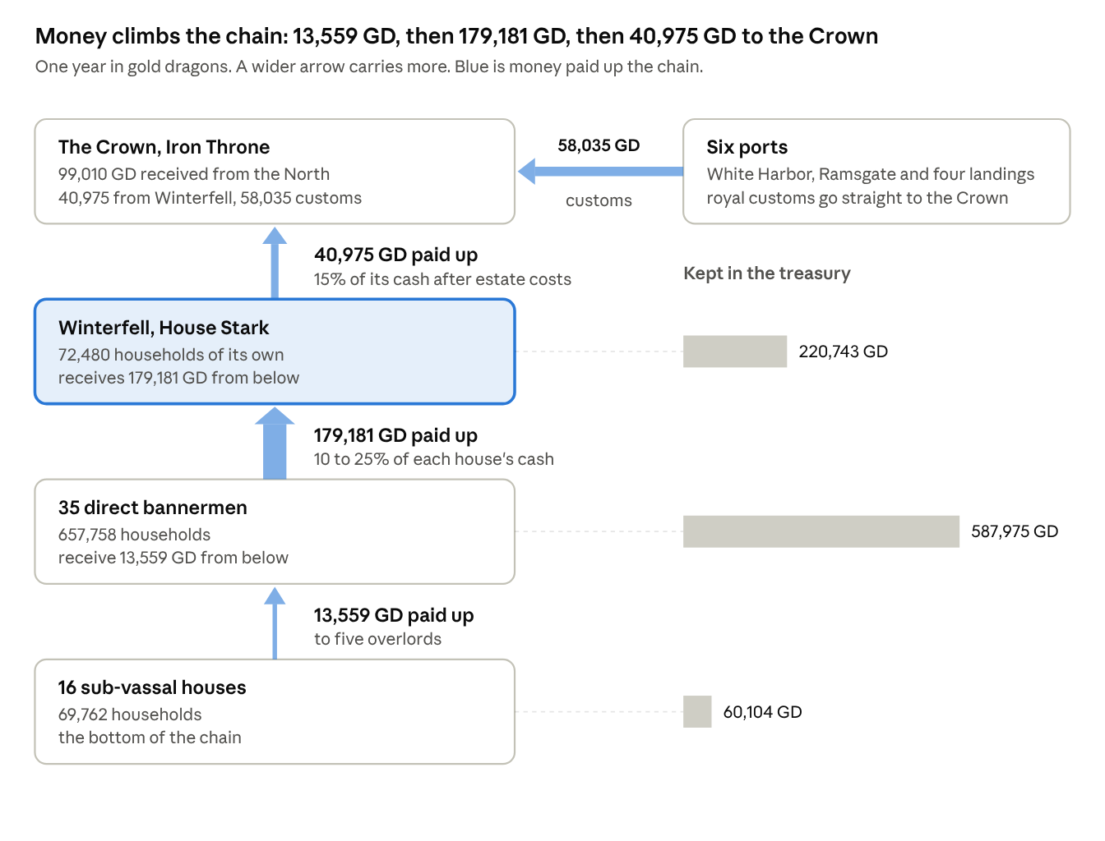
House Stark, one year, GD · from the workbook's House Accounts and Payments sheets
Read from the bottom up. Each level pays the one above it, and the bars on the right show what each level keeps. The 35 direct bannermen keep 587,975 GD between them, more than twice what Winterfell keeps.

Paid up to the Crown
Winterfell pays 15 percent of its cash receipts after estate costs, 40,975 GD, in two instalments of 24,585 and 16,390 GD. The Crown also collects royal customs at six ports, which go straight to it and never enter a house's account.
Crown receipt from the North | Base (GD) | Rate | Collected | Received (GD)
Winterfell's annual payment | 273,168 cash receipts | 15% | 100% | 40,975
Customs, White Harbor | 1,893,362 turnover | 2.5% | 99% | 46,861
Customs, Ramsgate | 227,203 turnover | 2.5% | 98% | 5,566
Customs, Oldcastle landing | 104,135 turnover | 2.0% | 97% | 2,020
Customs, Widow's Watch landing | 85,201 turnover | 2.0% | 97% | 1,653
Customs, Flint's Finger landings | 75,734 turnover | 2.0% | 96% | 1,454
Customs, Bear Island landings | 34,081 turnover | 1.5% | 94% | 481
Total received by the Crown |  |  |  | 99,010
The 15 percent is charged on all of Winterfell's cash, including the tribute it collects. Measured against Winterfell's own estate and grain income of 93,987 GD, the payment is 43.6 percent. The Crown takes 3.0 percent of the North's output, and customs are 59 percent of what it takes.

Immediate demands
Besides the Crown, the sheet records one fixed demand on Winterfell, the gift to the Night's Watch, paid in cash and in grain.
Demand on Winterfell | Cash (GD) | Grain (quarters)
Gift to the Night's Watch | 1,893 | 2,000: rye 800, barley 500, oats 400, peas and beans 200, wheat 100
The sheet adds no war levy, purveyance, confiscation windfall or marriage-pact income. Roads, bridges, landings and messengers are works the lord pays for himself, and appear under Household, castle and works.

Collected from the bannermen
Each bannerman pays a fixed share of the cash he has available, from 25 percent (Manderly) down to 10 percent (Magnar, Crowl and Stane), in two instalments of 60 and 40 percent. Collection runs from 94 to 99 percent. Each house also passes up 10 percent of the grain rent it receives and 20 percent of any grain sent from houses beneath it; Winterfell receives 50,409 quarters this way.
House (seat) | Households | Cash available (GD) | Rate | Due (GD) | Paid (GD) | Owing (GD)
Manderly (White Harbor) | 99,661 | 152,542 | 25% | 38,135 | 37,754 | 381
Bolton (Dreadfort) | 77,011 | 97,217 | 24% | 23,332 | 23,099 | 233
Dustin (Barrowton) | 54,360 | 69,261 | 23% | 15,930 | 15,771 | 159
Karstark (Karhold) | 49,830 | 63,947 | 22% | 14,068 | 13,928 | 141
Umber (Last Hearth) | 45,300 | 52,599 | 20% | 10,520 | 10,204 | 316
Ryswell (Rills) | 36,240 | 45,562 | 22% | 10,024 | 9,923 | 100
Glover (Deepwood Motte) | 31,710 | 44,596 | 21% | 9,365 | 9,272 | 94
Hornwood (Hornwood) | 31,710 | 40,805 | 22% | 8,977 | 8,887 | 90
Tallhart (Torrhen's Square) | 27,180 | 34,978 | 21% | 7,345 | 7,272 | 73
Cerwyn (Castle Cerwyn) | 27,180 | 35,757 | 22% | 7,867 | 7,788 | 79
Locke (Oldcastle) | 22,650 | 29,976 | 22% | 6,595 | 6,529 | 66
Flint of Flint's Finger | 18,120 | 23,879 | 20% | 4,776 | 4,728 | 48
The other 23 direct bannermen | 136,806 | 166,963 | 10 to 18% | 24,637 | 24,027 | 610
All 35 | 657,758 | 858,082 |  | 181,571 | 179,181 | 2,390
The first instalments bring in 107,509 GD and the second 71,673 GD. Rows are rounded. Manderly alone accounts for 21 percent of what is due, and the five largest houses for 56 percent.
↗ House Stark, one year, GD · Payments sheet, cash paid by each direct bannerman
The blue bars are the five houses that carry most of the load. Each of the other 30 pays 5.5 percent of the total or less.

Net tribute
Tribute is paid by one house and received by another, so it nets to zero across the North until it reaches the Crown. Winterfell is the one house that receives more than it pays.
Level | Paid up (GD) | Received from below (GD) | Net tribute (GD)
16 sub-vassal houses | 13,559 | 0 | -13,559
35 direct bannermen | 179,181 | 13,559 | -165,622
Winterfell | 40,975 | 179,181 | +138,206
The Crown, excluding customs | 0 | 40,975 | +40,975
Sum |  |  | 0
Risk, deficits and contingency tests what a heavier Crown demand, or a failure of the bannermen to pay, would do to these figures.

Household, castle and works
Winterfell's household, castle and works cost 11,450 GD, 4.2 percent of its cash receipts. The largest lines are building materials (2,745 GD), the Night's Watch gift (1,893), foot retainers (1,693) and non-grain provisions (1,518).
Item | Quantity | Unit price (GD) | Cost (GD)
Foot retainers | 447 man-years | 3.787 | 1,693
Mounted retainers | 45 man-years | 7.573 | 341
Household servants | 82 person-years | 1.136 | 93
Central account clerks | 21 person-years | 5.680 | 119
Stewards | 4 person-years | 18.934 | 76
Non-grain provisions | 4,010 ration-years | 0.379 | 1,518
Livery and clothing | 595 person-years | 0.189 | 113
Arms and armour upkeep | 492 armed retainer-years | 0.284 | 140
Replacement riding horses | 5.4 head | 2.840 | 15
Castle masons and carpenters | 41.2 craft worker-years | 5.680 | 234
Building materials | 72,480 household-years | 0.0379 | 2,745
Roads, bridges and landings | 72,480 household-years | 0.0189 | 1,372
Messengers and official travel | 72,480 household-years | 0.0095 | 686
Godswood care and alms | 72,480 household-years | 0.0057 | 412
Cash gift to the Night's Watch | 1 gift | 1,893.36 | 1,893
Total |  |  | 11,450
The household scales with the lordship. Foot retainers are 0.006 per household plus 12, mounted retainers 0.0006 per household plus 2, servants 0.001 plus 10, clerks 0.0003 plus 2, and stewards one plus one for every four estates. Works are charged as a small contribution per household.
Retainers, servants and estate workers also eat grain from the granary, 4,411 quarters a year for the household, which is in the grain account and not in this table. The standing force is 447 foot and 45 mounted retainers; the sheet fields no levy of bannermen because it assumes no war. Across the North the 52 houses spend 114,096 GD on household, castle and works, 3.5 percent of output.

The annual account: charge and discharge
On the audit Winterfell is charged with 533,632 GD, discharges 62,889 GD, and carries forward 470,743 GD. The charge is everything the lord has to answer for: the opening treasury and every receipt. The discharge is everything he can show he paid out.
Charge (GD) | Amount
Opening treasury, brought forward | 250,000
Cash rents of tenants | 47,781
Lord's share of livestock, wool and dairy | 27,178
Mills, markets and courts | 8,330
Timber and fishery leases | 4,873
Grain sold from the granaries | 16,289
Tribute from 35 bannermen | 179,181
Receipts of the year | 283,632
Total charge | 533,632

Discharge (GD) | Amount
Estate running costs, paid before remittance | 10,464
Household, castle and works | 9,557
Gift to the Night's Watch | 1,893
Paid to the Crown | 40,975
Total discharge | 62,889
Balance carried forward | 470,743
The year's surplus is 220,743 GD, which is receipts of 283,632 less the discharge of 62,889. The balance is cash only: it leaves out plate, land and stored produce, and arrears are receivables, not coin. Rows are rounded from exact figures.
The account is audited five ways:
- Each estate receiver's gross receipts less his costs equals what he remitted: 88,162 less 10,464 is 77,698 GD.
- Tribute received by Winterfell equals tribute paid by the 35 bannermen: 179,181 GD on both sides.
- The Crown payment is 15 percent of cash receipts after estate costs: 15 percent of 273,168 is 40,975 GD.
- The treasury rolls forward: 250,000 plus the surplus of 220,743 is 470,743 GD.
- The grain account closes in quarters, shown under Where the harvest went.

The seasonal calendar
Cash reaches Winterfell in two instalments, 60 percent and 40 percent, and the sheet fixes no dates for them. The stages below follow the sheet's order; the months are the house's to set.
Stage | Cash in (GD) | Cash out (GD) | Treasury after (GD)
Opening treasury |  |  | 250,000
First instalment: rents 28,669 and tribute 107,509 in; Crown 24,585 out | 136,178 | 24,585 | 361,593
Second instalment: rents 19,113 and tribute 71,673 in; Crown 16,390 out | 90,785 | 16,390 | 435,988
Through the year, undated: stock, leases, mills, markets, courts and grain sales in; estate costs, household and the Watch gift out | 56,670 | 21,914 | 470,743
Rows are rounded from exact figures, so a rent or tribute split may differ from its total by 1. Grain keeps its own calendar: the harvest fills the granary, seed is drawn for the next sowing, the retinue and workers draw food through the year, and Winterfell sells its surplus. That is in the grain account.
↗ House Stark, one year, GD · same figures as the calendar table above
Grey is what the treasury already held. Dark is what each step added once its outgoings were paid.
Three practical points follow from the stages:
- After the first instalment alone Winterfell holds 361,593 GD against a year's outgoings of 62,889 GD, so it never has to borrow.
- The Crown's two payments are covered at once: 24,585 GD falls due against 136,178 GD received in the same stage, and 16,390 GD against 90,785 GD.
- Outgoings other than the Crown run through the year. If spread evenly they are about 1,826 GD a month, an assumption the sheet does not state.

Risk, deficits and contingency
No stress test opens a cash deficit at Winterfell or at any other house. I recalculated the workbook under three changes to its own inputs, and the treasury stays well above zero in each.
Test | Winterfell cash received (GD) | Paid to the Crown (GD) | Surplus kept (GD) | Closing treasury (GD)
Base year | 273,168 | 40,975 | 220,743 | 470,743
Rents remitted 15 percent instead of 2 | 254,820 | 38,223 | 205,147 | 455,147
Bannermen pay half of what they now pay | 182,885 | 27,433 | 144,002 | 394,002
Crown takes 25 percent instead of 15 | 273,168 | 68,292 | 193,426 | 443,426
The tests are mine, not the workbook's, and each changes one input. Forgiving rents costs Winterfell 15,596 GD of surplus. Half-payment by the bannermen costs 76,741 GD, but arrears across the North rise from 2,584 to 98,244 GD, and the Crown loses 13,542 GD because its share is a fixed 15 percent of Winterfell's cash. A 25 percent Crown share costs Winterfell 27,317 GD.
↗ House Stark, one year, GD · stress tests on a copy of the workbook
Bannermen paying half is the test that matters, because tribute is 66 percent of the cash Winterfell receives.
A harvest failure cannot be tested honestly in this sheet. Cutting every crop yield by 30 percent lowers the North's harvest from 11.41 to 7.98 million quarters. The sheet's market then imports 1.83 million quarters at unchanged prices and stops exporting 1.35 million. Because the sheet pins output at 3,300,000 GD, it also raises every price to compensate, so Winterfell's cash rents rise from 47,781 to 51,073 GD. Read that result as quantities only.
Three cautions follow:
- Reserve. Winterfell opens with 250,000 GD, four years of its 62,889 GD outgoings, and ends the year with seven and a half.
- Concentration. Manderly owes 38,135 GD, 21 percent of the tribute and 14 percent of Winterfell's cash. The five largest houses owe 56 percent.
- Arrears. Tenants owe 1.9 percent of Winterfell's cash rent after remission and bannermen 1.3 percent of tribute. Small arrears are cheap to collect and dear to forget.

Where the harvest went: the grain account
Winterfell's granary starts the year with 70,777 quarters, takes in 338,087 more, uses 100,250, sells 236,735 and ends with 71,879. Grain is kept in quarters and never mixed with the cash account.
↗ Winterfell, one year, quarters of 8 bushels · the grain account
Winterfell sends no grain to the Crown; it sends cash. It buys no grain.
Crop | Stock before market (q) | Sold (q) | Sold for (GD) | Closing stock (q)
Rye | 87,821 | 69,941 | 4,414 | 17,880
Barley | 82,959 | 63,730 | 4,597 | 19,228
Oats | 75,393 | 52,564 | 2,370 | 22,829
Peas and beans | 38,165 | 30,808 | 2,778 | 7,357
Wheat | 24,276 | 19,692 | 2,131 | 4,584
Total | 308,614 | 236,735 | 16,289 | 71,879
Across the North the harvest is 11,405,588 quarters. Seed takes 3,615,871, food for 4,000,000 people 4,400,000, animal feed 445,600 and loss 929,859. The North exports 1,347,318 quarters, imports none, and adds 664,940 to stock, which closes at 7,182,803 quarters. Rows are rounded.

Glossary of terms
The terms this sheet uses, in alphabetical order, in plain words.
Term | Meaning
Arrears | Rent or tribute owed and not yet paid. A receivable, not coin in the chest
Bannerman | A house sworn to a higher house, which pays it tribute
Cash available | A house's net estate cash, grain sales, harbour dues and tribute received; the base for what it pays up
Charge and discharge | The account form: what the lord is charged with, less what he can show he paid out
Collection rate | The share of what is due that is actually paid, 90 to 99 percent by district
Crown payment | Winterfell's yearly cash to the Iron Throne: 15 percent of its cash receipts after estate costs
Customs, royal | The Crown's duty on port trade, collected at the port and never passing through a house
Demesne | The one-fifth share of farm output the lord keeps; tenants hold the other four fifths
Estate | A group of villages, fields and leases under one receiver; Winterfell has 12, the North 163
GD | Gold dragon, worth 210 stags; the unit of every cash account
Godswood | The grove of the old gods; its care and alms are a cost, not a tithe
Harbour dues, local | A rate on port trade kept by the house that holds the port
Holding class | Full farm, smallholding, croft and cottage, or town plot; it sets the rent
Instalment | A payment in two parts, 60 percent then 40 percent
Output | Value added in the year; rents and tribute move it between hands and are never added to it
Quarter | Eight bushels of grain; the unit of every grain account
Receiver | The officer who collects an estate's cash and remits it to the house
Remission | The lawful 2 percent cut from assessed rent before it is collected
Retained cash | What a house keeps after costs and payments up: its surplus for the year
Rural household | A household that farms; it sows 14 acres. Town households do not
Stag | Silver coin of 56 pennies, 1/210 of a dragon
Sub-vassal | A house that pays another bannerman and not Winterfell directly
Tithe | A tenth of produce owed to a church; none is levied in the North
Treasury | A house's stock of coin; opening and closing balances are cash only
Tribute | Cash paid up the chain from a lower house to a higher one
Old English terms such as scutage, purveyance, relief and wardship have no entry because the sheet's ordinary year contains none of them.

Notes, assumptions and variation
Every figure comes from the North 126 AC fiscal model and is a simulation choice, not a record. The houses and their documented allegiances are the setting; the rents, prices, shares and household counts are the model's. The cash scale is the model's own: 3,300,000 GD of output for the North, and every figure here sits on it.
Assumption | Value
North output | 55% of the 6,000,000 GD Westerlands benchmark, 3,300,000 GD
People per household | 5
Grain food per person | 1.1 quarters a year
Demesne share of farm output | 20%
Sown acres per rural household | 14
Harvest loss | 5% of the gross harvest
Tenant grain rent | 7% of the tenant harvest
Lawful remission of rents | 2%
Winterfell's payment to the Crown | 15% of cash receipts after estate costs
Cash instalments | 60% then 40%
Gift to the Night's Watch | 2,000 quarters and 1,893 GD a year
Coin and measure | 210 stags to the dragon, 56 pennies to the stag, 8 bushels to the quarter
Four things to bear in mind when reading the figures:
- Prices follow output. They are scaled so the North's output hits 3,300,000 GD, and households, acres and quarters are typed in, so changing the 55 percent rescales every GD figure and no quantity.
- Port turnover is a typed assumption, not derived from the grain the North sells, and royal customs, 59 percent of the Crown's take, rest on it.
- The Crown's 15 percent is charged on all of Winterfell's cash, tribute included.
- Every rural household sows 14 acres whatever its holding class, so a croft pays a seventh of a full farm's rent for the same acreage.
What the sheet leaves out by rule: any general tithe, the Gift and New Gift, a war levy, confiscation windfalls, new mines, any 129 AC income, debt and interest. Cash balances exclude plate, land and stored produce. There is no cash account for tenant households.
To adapt the sheet to another house, change the Crown share, then the bannermen's rates, then the rent per holding class, in that order. They move the surplus most.

